Anneka Lenssen

328 words

**Nabaa, Nazir (Born Damascus, Syria, 1938)**

Nazir Nabaa, a respected Syrian painter, made his greatest contributions to Arab modern art in the 1960s and 1970s, when he contributed to the graphic identity of progressive political causes and the Palestinian liberation struggle. He joined the Syrian Communist Party in the 1954 and in 1959 was briefly jailed for this affiliation. After his release, he traveled to Cairo on a fellowship to study painting at the Faculty of Fine Arts, there developing a heroic realist style around social and labour themes. After returning to Syria in 1964, Nabaa taught drawing in rural schools and worked with myth and folklife. Moving to Damascus in 1968, he worked as an illustrator and became involved in creative projects in support of political mobilisation, including poster design, puppet theatre, fine art painting, and art criticism. Between 1971 and 1975, Nabaa studied in Paris at the Academy of Fine Arts. Upon his return, he joined the faculty of the College of Fine Arts in Damascus. His later paintings became more fantastical, combining goddess figures with still lifes of fruits, tapestries, and jewellry. He also developed a parallel corpus of abstract paintings based on the exploration of texture and colour.

**References and further reading**

Abdelke, Youssef and Nazir Nabaa (2009) *An Eye on the World...An Eye on the Soul*, Damascus: Tajalliyat Gallery. (Contributor’s comment: monograph with autobiographical commentary published on the occasion of a monographic exhibition in Damascus).

Atassi, Mouna, and Samir Sayegh (1998) *Contemporary Art in Syria, 1898-1998*, Damascus, Syria: Gallery Atassi. (Contributor’s comment: Most comprehensively illustrated volume on modern Syrian art).

Lenssen, Anneka (2013) ‘The Plasticity of the Syrian Avant-Garde, 1964-1970’, *ARTMargins* 2 (2): 43–70. (Contributor’s comment: discusses Hammad’s early abstract paintings in relation to international stylistic currents and political tensions in Syria).

Al Sharīf, Tāriq (1972) ʿ*Ishrūn Fannānan min Suria (Ten Artists from Syria)*, Damascus, Syria: Ministry of Culture. (Contributor’s comment: Includes a chapter on Hammad, with a detailed reading of his artistic practice up until 1972).

**Paratextual material**

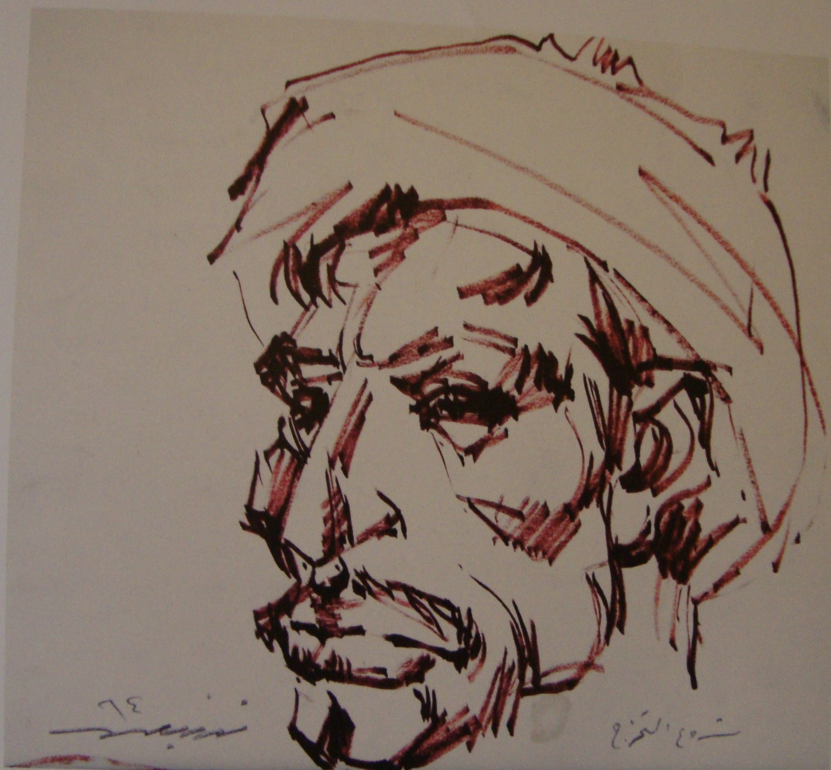

Nazir Nabaa, preparatory sketch for graduation project, 1964, marker on paper, 29x26cm.

Source: Artist’s collection. Reproduced in Youssef Abdelke and Nazir Nabaa (2009) *An Eye on the World...An Eye on the Soul*, Damascus: Tajalliyat Gallery.